**Project Report**

**On**

**Analysis of Paytm**

**Submitted By:**

Tejas Harish Borkar (2K18/CO/373)

Tushar Ahuja (2K18/CO/374)

**Under the Guidance of**

Ms. Kamini Mishra

Research Scholar



**Department of Computer Engineering**

**Delhi Technological University**

**May 2021**

**INDEX**

|  |  |  |  |
| --- | --- | --- | --- |
| **S no.** | **Title** | | **Page no.** |
| 1. | Introduction | | 3 |
| 2. | Organizational Structure | | 4-6 |
| 3. | PESTEL Analysis | Political Factors | 7-8 |
| Economic Factors | 8 |
| Social Factors | 8-9 |
| Technological Factors | 9 |
| Environmental Factors | 10 |
| Legal Factors | 10 |
| 4. | SWOT Analysis | Strengths | 11-12 |
| Weaknesses | 12 |
| Opportunities | 12-13 |
| Threats | 13 |
| 5. | Corporate Social Responsibility | | 14-15 |
| 6. | Framework for Corporate governance | | 15-16 |
| 7. | Managerial Values and ethics | | 16-17 |
| 8. | Marketing Strategy | Product | 17-18 |
| Price | 18 |
| Place | 18 |
| Promotion | 18-19 |
| 9. | Targeted customers | | 20 |
| 10. | Alliances and Partnerships | | 20-21 |
| 11. | Recent/Upcoming Projects | | 22 |
| 12. | Unethical issues in Market Environment | | 22-24 |
| 13. | Financial Performance | | 24-27 |
| 14. | Scope Of Improvement | | 27-28 |
| 15. | References | | 28 |
| 16. | Bibliography | | 28 |
| 17. | Plagiarism Check on Grammarly | | 29 |



Figure 1: Paytm logo

**1. INTRODUCTION**

* One97 Communications Ltd established “Pay Through Mobile” which is popularly known as PayTM in August 2010 as a prepaid mobile recharge website and later PayTM moved to e-commerce
* Paytm was founded with an initial investment of $2 million by Vijay Shekhar Sharma.
* Users can add money to Paytm’s integrated wallet using their debit cards, credit cards , UPI ,etc.
* Users can make payments for electricity bills, metro cards , phone bills,etc.
* Additionally, it also enables users to buy goods from its e-retail platform.
* Paytm has also entered m-commerce which enables business owners to list their products on its platform.
* It is highly secure and reliable and is approved by the Reserve Bank of India

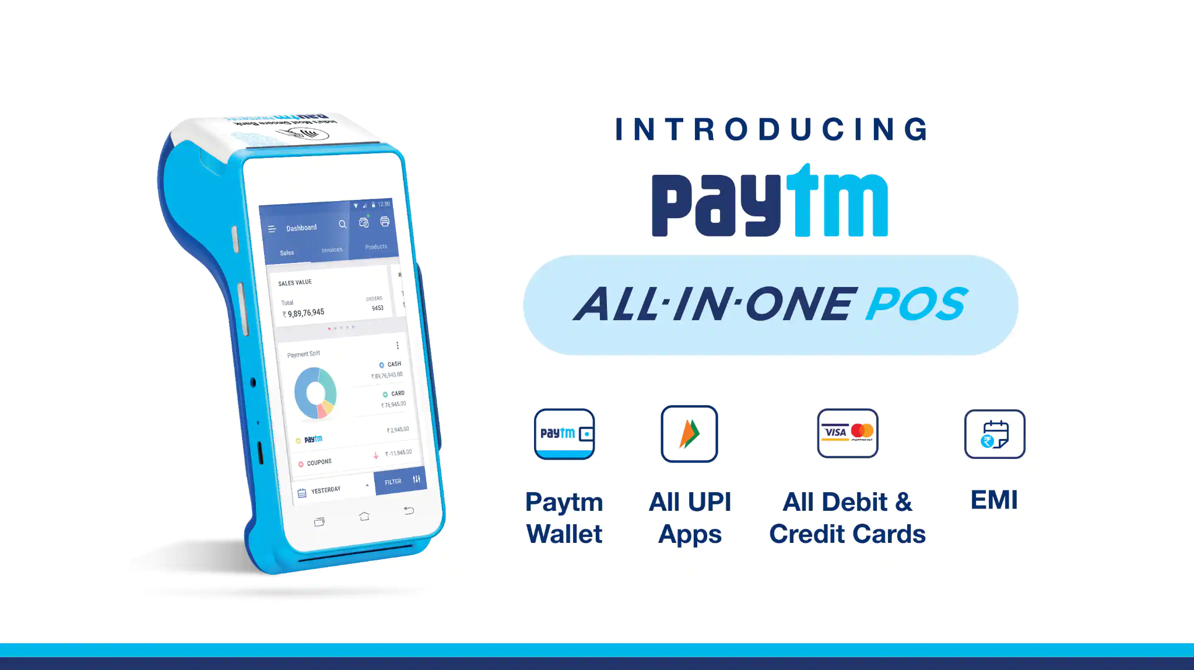

Figure 2 : Paytm services

**2. ORGANISATIONAL STRUCTURE**

* An organizational structure is a system that outlines how certain activities are directed in order to achieve the goals of an organization. These activities can include rules, roles, and responsibilities.
* The organizational structure also determines how information flows between levels within the company. Having an organizational structure in place allows companies to remain efficient and focused.

For this section we have used data from **One97 Communications Limited annual report 2018-2019.**

During the time frame under survey, following Directors had surrendered/stopped to be chief:

* Mr. Amitabh Kumar Singhal with effect from 01.03.2019.
* Mr. Kabir Misra with effect from 01.03.2019.
* Mr. Saurabh Jalan with effect from 01.03.2019

Further, the accompanying Directors were designated during the time frame under audit:

* Mr. Saurabh Jalan as an Alternate Director to Mr. Kabir Misra with impact from 06.04.2018.
* Mr. Mukul Arora as an Alternate Director to Mr. Ravi Chandra Adusumalli with impact from 18.05.2018.
* Mr. Munish Ravinder Varma as an Additional Director with impact from 01.03.2018-Investor Director by SVF India
* Holdings (Cayman) Limited. Further, he was designated as a Director of the Company in the Extra-ordinary general meeting of the Company hung on March 22, 2019.
* Mr Kabir Misra and Ms. Pallavi Shardul Shroff who were designated as extra chief, regularized and were named as Director of the Company at the Annual General Meeting hung on September 28, 2018.

The Company has gotten an announcement from the Independent Directors proclaiming that they meet the criteria of Independence as far as Section 149(6) of the Companies Act, 2013 and that there is no adjustment in their status of Independence.

During the time frame under survey, Mr. Madhur Deora and Mr. Vimal Chawla keep on standing firm on the footing of Chief Financial Official and Company Secretary, separately, of the Company.

Further, Mr. Vimal Chawla, Company Secretary of the Company has left the Company with effect from May 8, 2019. The Company is currently distinguishing the substitution and will make the arrangement at the soonest.

Regarding the arrangements of Section 152 of the Companies Act, 2013, Mr. Vijay Shekhar Sharma and Mr. Jing Xiandong, Director of the Company, are at risk to resign by pivot at the following Annual General Meeting of the Company and being

qualified, offer themselves for reappointment.

As on date of the report the synthesis of Board of Directors is as beneath:

|  |  |  |
| --- | --- | --- |
| **S.NO** | **Name** | **Designation** |
| 1 | Vijay Shekhar Sharma | Managing Director |
| 2 | Mr. Ravi Chandra Adusumalli | Director |
| 3 | Mr. Jing Xiandong | Director |
| 4 | Mr. Joesph Chung Tsai | Director |
| 5 | Mr. Munish Ravinder Varma | Director |
| 6 | Mr. Mark Schwartz | Director |
| 7 | Ms. Pallavi Shardul Shroff | Director |
| 8 | Mr. Chen Yan | Alternate Director |
| 9 | Mr. Ting Hong Kenny Ho | Alternate Director |
| 10 | Mr. Mukul Arora | Alternate Director |

**COMMITTEES OF BOARD OF DIRECTORS:**

The Company has following legal advisory committees of Board as needed under the Companies Act, 2013 as at 31st March,2019:

1. Audit Committee
2. Nomination and Remuneration Committee
3. Corporate Social Responsibility Committee

As on the date of this report, the synthesis of the committees according to appropriate arrangement of the Companies Act, 2013 furthermore, rules are as under:

|  |  |
| --- | --- |
| **Name of the Committee** | **Composition of Committee** |
| Audit Committee | * Mr. Mark Schwartz, Member * Mr. Ravi Chandra Adusumalli, Member * Ms. Pallavi Shardul Shroff, Member |
| Nomination and Remuneration Committee | * Mr. Ravi Chandra Adusumalli, Member * Mr. Jing Xiandong, Member * Mr. Mark Schwartz, Member * Ms. Pallavi Shardul Shroff, Member |
| Corporate Social Responsibility Committee | * Mr. Vijay Shekhar Sharma, Member * Mr. Ravi Chandra Adusumalli, Member * Mr. Mark Schwartz, Member |

**3. PESTEL ANALYSIS**

* PESTEL Analysis is used to evaluate the external environment of a business by breaking down the various opportunities ,risks and decisions into Political, Economic, Social, Technological, Environmental, and Legal factors.
* PESTEL Analysis is an effective way to plan as per the external factors and to also figure out the pros and cons of the various external factors on the business.

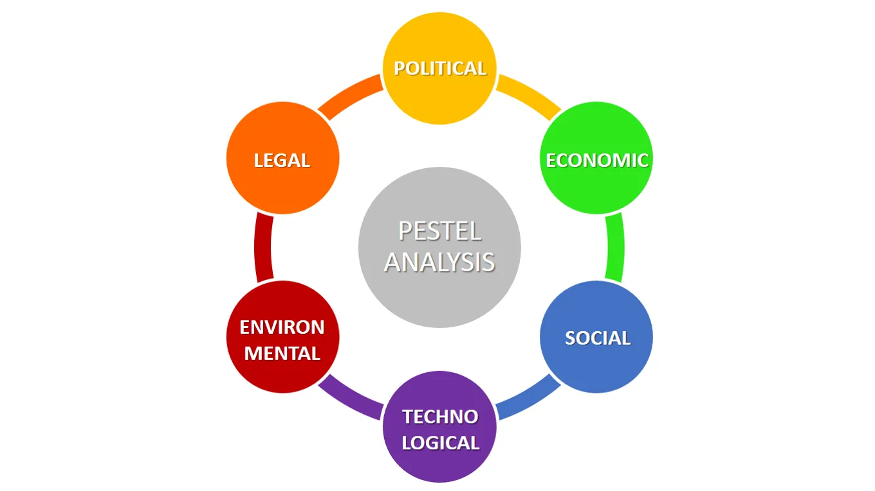

Figure 3: Pestel Analysis

## **Political Factors:**

## These factors are concerned with the influence of government policies, political stability or instability, corruption, foreign trade policy, tax policy, labour law, environmental law and trade restrictions.

## The government may have a profound impact on a nation’s education system, infrastructure and health regulations and it is therefore necessary to study the effect of these factors.

## The political factors that affect Paytm are :

1. **Size of Government Budgets** : The governments at the national level and local levels define budgets in order to boost growth. Since the budget increases or decreases the government’s spending in a certain field it directly or indirectly affects Paytm in the short term as well as the long term.
2. **Regulatory Practices** : The governments introduce certain guidelines for companies in order to regulate them to prevent them from engaging in any unethical practices. Such regulations also affect Paytm as they need to strictly adhere to them and hence formulate their decisions based on these regulations.
3. **Demonetization** : The central government demonetized ₹ 500 and ₹1000 notes in November 2016. Since there was limited supply of new notes , the public had to now look for alternatives to cash. This is where Paytm came into play and gained popularity. So demonetization was a boon for Paytm.
4. **Digital India** : Digital India was a campaign launched by the Government of India in order to promote digitization .This led to improved internet connectivity around India and the number of mobile phone users also increased. This is where Paytm assessed the situation and using their aggressive advertisement strategy they were able to target a significant section of the society.

## **Economic Factors:**

## These Factors include economic growth, exchange rates, inflation rates, interest rates, disposable income of consumers and unemployment rates.

## Such factors may have a direct or an indirect impact on the company since it affects the price of goods and services provided by the company.

## They also may affect the purchasing power of the consumers and hence vary the demand and supply.

## The economic factors that affect Paytm are :

1. **Affordable smartphones and internet** : Since Paytm’s inception , smartphones and internet have become more and more affordable. Therefore the number of active internet users has increased with time and hence Paytm is now able to target a larger section of consumers.
2. **Increase in per capita income** : Increased earning leads to increased spending. Therefore people are now able to spend much more on smartphones and the internet . Therefore Paytm is able to attract more users to pay for goods and services through its platform.
3. **Inflation rate** : A change in the inflation rate may change the prices of goods and services being provided by Paytm and it also affects the consumers. Consumers may choose to keep using Paytm or move to its alternatives. Therefore it varies the consumer base of Paytm.

## 

## **Social Factors:**

* These factors include population trends such as the population growth rate, age distribution, income distribution, career attitudes, safety emphasis, health consciousness, lifestyle attitudes and cultural barriers.
* These factors play a crucial role as it affects the decisions of the marketing department and the company’s overall strategy while targeting certain consumers.

The social factors that affect Paytm are :

1. **Increase in online shopping** : This is a lifestyle change. The number of users purchasing goods online has increased significantly over time. The reasons for this increase are
   1. Ease of payments
   2. Variety of products
   3. Hassle free returns on most items
   4. Convenience to order

Paytm is benefited directly when consumers purchase goods from their platform and indirectly when consumers pay using Paytm on other platforms.

This has led to an increase in the number of transactions taking place on a daily basis.

1. **Birth Rate** : An increase in the birth rate is a good sign for Paytm as they can target more consumers in the long run.

## **Technological Factors:**

* This refers to technology incentives, the level of innovation, automation, research and development (R&D) activity, technological change and the amount of technological awareness that a market possesses.
* These factors play a vital role as a company needs to plan its decisions accordingly. Launching an app in an area with poor internet coverage or less smartphone users may not be the best idea.
* This helps the company to stay profitable in the long run by staying updated with the technological advancements and using them to their advantage.

The technological factors that affect Paytm are :

1. **Cheap Internet and Increase in the number of internet users** : Due to the advent of Jio in the Indian market , accessing the internet has become very affordable. Therefore the internet is now accessible to more users and this has helped Paytm grow.
2. **Most of the internet users access the internet using their smartphones** : Due to this , there is an increase in the number of mobile app users. Therefore Paytm app has become more popular and this has helped Paytm grow over the years.

## 

## **Environmental Factors:**

* These factors include ecological and environmental aspects such as weather, climate, environmental offsets and climate change.
* Since resources are scarce and there are certain standards set by the governments on pollution and carbon footprints, the companies need to use the resources judiciously.
* These factors also affect the way a company operates.

The environmental factors that affect Paytm are :

1. **Extreme Climate/ Widespread disease outbreak** : This may force the user to pay for services or order products online instead of visiting certain offices or shops for the same.
2. **Natural calamities** : It may affect the supply chain of its goods and therefore affect the business and the consumers.

## **Legal Factors:**

* Although these factors may have some overlap with the political factors, they include more specific laws such as discrimination laws, antitrust laws, employment laws, consumer protection laws, copyright and patent laws, and health and safety laws.
* The companies need to be aware of the legality of what they are doing in order to make suitable decisions.
* Any changes in the legal structure may affect the organization and thugs they need to remain up to date with the laws.
* In case of a multinational corporation, these factors become even more important due to different rules and regulations in different countries.

The legal factors that have affected Paytm are :

1. **Postpaid wallet offering** : Paytm got into a legal tussle regarding its postpaid wallet offering. The legality of the postpaid wallet was questioned by a Public Interest Litigation. It stated that even though Paytm wasn’t licensed for credit or loan related services ,it was granted a payments bank license
2. **Similar color scheme and logo as of Paypal** : Paytm has faced some legal issues when Paypal filed an infringement case against them. Paypal accused Paytm of copying their color scheme for their logo. They also accused Paytm for using the word “pay” in their name that was similar to Paypal.

**4. SWOT ANALYSIS**

* SWOT stands for Strengths, Weaknesses, Opportunities, and Threats.
* SWOT Analysis is a technique for assessing these four aspects of a business.

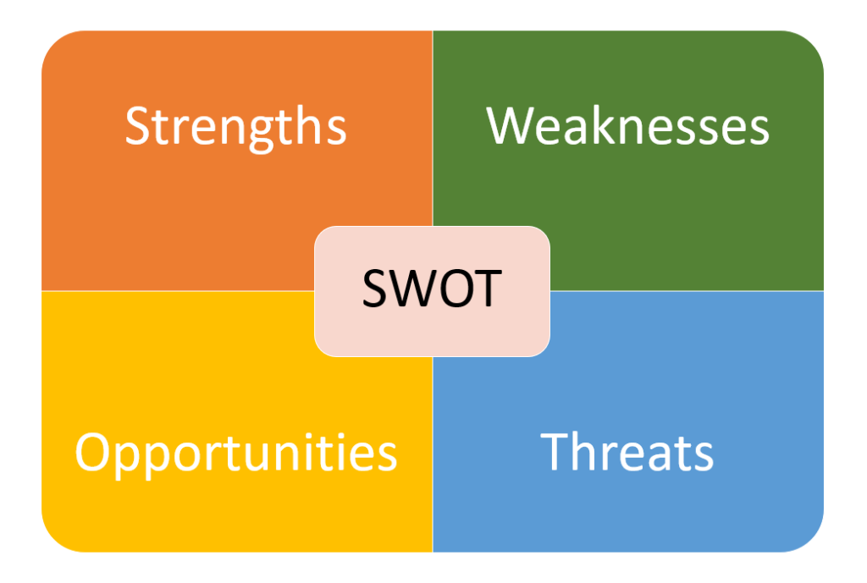

Figure 4 : SWOT Analysis

**Strengths in SWOT Analysis**

Strengths are characterized as what every business is best in its extent of tasks which can give it an advantage over its rivals. The following are the strengths of Paytm:

* **First mover advantage:** Paytm was one of the first online payment companies to set up its operations in India. Their planning was wonderful since they began tasks at around a similar time when smartphones began getting popular.
* **Convenience:** Paytm is very convenient to use and allows transfer of funds from anywhere, anytime. This makes it progressively acknowledged by a metropolitan population who depend on the internet looking for even day by day use things.
* **Relations with merchants**: Paytm can be used to transact with more than 3 million

merchants across India. This is increasing day by day and therefore this makes Paytm an easy payment option for most customers.

* **Bucket of Services:** Paytm has plenty of services like movie/flight tickets booking , money transfer , DTH payments , bill payments, etc. that helps users to use only a single platform for most of their needs.
* **Offers:** The offers provided by Paytm for payments through its platform attract customers. They provide offers in the form of cashbacks, discounts , etc, to lure customers.
* Other strengths are huge population to target, compatible for all devices, user friendly and easy way of payments and strong marketing campaigns. These have helped them to spread brand awareness.

**Weaknesses in SWOT Analysis**

Weaknesses are utilized to allude to zones where the business or the brand needs improvement. A portion of the critical weaknesses of Paytm are:

* **Needs IT Infrastructure:** If Paytm capacities must be powerful there must be acceptable data transmission and speed. This might be there in many urban areas in India however this may not be the situation in far off areas.
* **Lack of awareness amongst users:** Most users are ignorant of how Paytm can help them and confused about how the application should be utilized. The degree of familiarity with innovation devices and the natural dread of making mistaken exchanges is worsening the situation.
* **Fear of going cashless :** Most Indians are accustomed to executing on cash as most of them are less tech-savvy and they prefer cash payments since cash has been the medium of exchange over the years. Such people are yet to become aware of online transactions.
* **Poor customer support:** One analysis leveled against Paytm is its poor customer support. It is affirmed that the call center heads are frequently inconsiderate and incapable to deal with a large number of the queries.
* Some other weaknesses are slow servers (server problems), unable to handle traffic when new offers are introduced etc.

**Opportunities in SWOT Analysis**

* **Developing interest for aggregators:** An aggregator is an element that buys contracts from monetary establishments and afterward securitizes them into contract supported protections (MBSs). Aggregators can be the responsible banks of the home loans or auxiliaries inside the monetary establishments themselves. Aggregators and middlemens are in demand wherever today. With developing innovation, individuals like to make most payments from the accommodation of their homes.This has expanded the part of payment aggregators in India.
* **Demonetisation**: One of the administrations that profited intensely from the Indian government's demonetization drive was online payment administrations and Paytm was probably the greatest recipient. In a transition to digitize the nation, such administrations will have more freedoms coming their direction.
* **The flood in the quantity of working professionals:** The quantity of working experts are expanding bountifully. This implies that for most couple's time is scant causing them to depend more on home delivery services. At the point when the interest for web based shopping builds there will be a related expansion in the payment gateways as well.
* Other opportunities are increased brand awareness and awareness of the app among users, increased internet users' daily needs, growth of E-commerce in recent periods etc.

**Threats** **in SWOT Analysis**

Threats are those elements in the environment which can be negative to the development of the business. A portion of the Threats include:

* **Fierce competition**: There are a great deal of online entries like paypal, mobikwik and so on and even telecom specialist organizations like Airtel and Vodafone are giving on the web installment entryways. These payment gateways provide fierce competition to Paytm and are a threat to them.
* **Developing worries about safety**: Today there is negative symbolism of data security and tracking of shopping propensities. There is likewise developing worries about how safe the data submitted to payment portals are and the level to which such entries or payments made through them are observed.
* There are many areas in India where there are internet connectivity problems or no internet connections, so this could be a threat to the company.

**5. CORPORATE SOCIAL RESPONSIBILITY**

* Corporate social responsibility (CSR) is a self-regulating business model that helps a company be socially accountable—to itself, its stakeholders, and the public.
* By practicing CSR a company becomes aware of the impact of its actions in the society.

Paytm has stood for the following activities as part of CSR :

1. **Donation to Bhopal Gas Tragedy survivors** : Paytm donated towards the rehabilitation of the survivors of the Bhopal Gas Tragedy but the exact amount wasn’t disclosed. Paytm also requested its users to donate where the users could select coupons worth Rs.50, Rs.100, Rs.250 and Rs.500 to donate towards this noble cause.
2. **Independence Day Campaign for the future of India- Skill training of youth** : Under this campaign funds were raised in order to empower the youth. Paytm donated ₹537,273 towards this cause.
3. **Donation to the PM-Cares fund during Covid-19**  : Paytm decided to contribute ₹10 for every single user who pays to the PM CARES fund via their app. Paytm was able to collect over 100Cr through their App in 10 days. Their 1,200 employees have contributed their 15 days or even a few months of their salaries to the fund.
4. **Joy of Giving Week** : In October 2009 , Paytm participated in Joy of Giving week to collect and contribute clothes and other items to Goonj that distributed them to the disaster hit regions of the country.
5. **J&K Floods Campaign** : It was a special initiative to provide assistance to the victims of the Jammu and Kashmir floods where Paytm matched each donation rupee for rupee and the proceeds were donated to the Prime Minister’s National Relief Fund.
6. **Republic Day Campaign for the underprivileged soldiers & families** : Paytm donated its profits on 26th Jan 2014 to support the differently-abled children, widows and differently-abled soldiers.
7. **Uttarakhand Floods Campaign** : Paytm donated Rs. 20,10,862 to the Uttarakhand CM Relief Fund to aid the Uttarakhand flood victims and help the government's rebuilding efforts in the region.
8. **Diwali Campaign for the Blind** : Paytm donated profits earned on transactions made on Diwali days during 2013 to the National Association for the Blind.This helped to support the education of blind girls, their vocational training and food.

**6. FRAMEWORK FOR CORPORATE GOVERNANCE**

* Corporate Governance refers to practices by which organisations are controlled, directed and governed.
* The fundamental concern of Corporate Governance is to ensure the conditions whereby organisation's directors and managers act in the interest of the organisation and its stakeholders and to ensure the means by which managers are held accountable to capital providers for the use of assets.
* To achieve the objectives of ensuring fair corporate governance, the Government of India has put in place a statutory framework.
* Corporate governance reports provide assurance to the stakeholders that corporations are committed to good corporate governance i,e company is not favouring a particular stakeholder only and company is complying with all applicable laws and regulation.

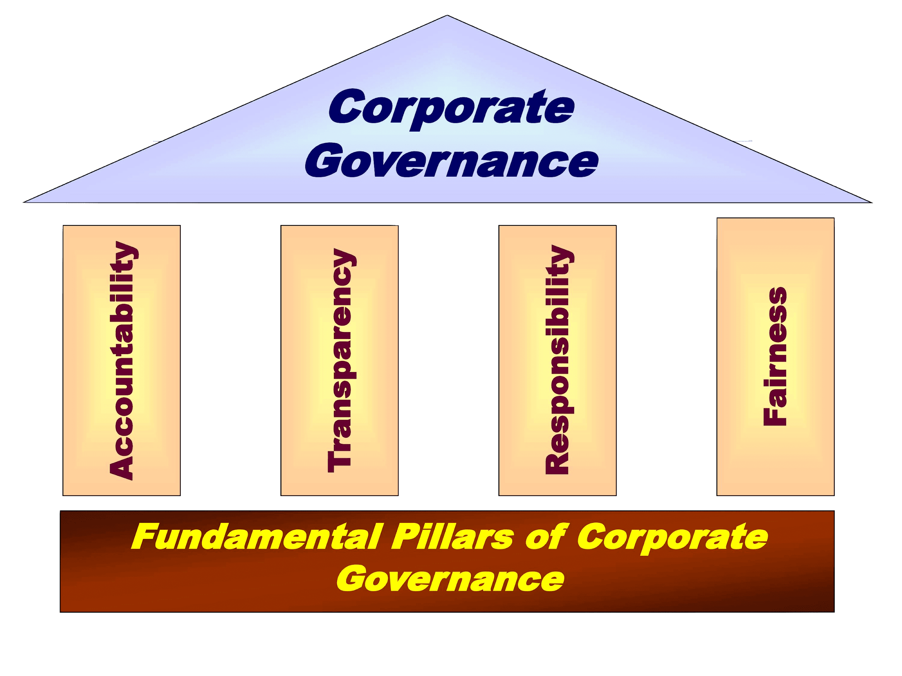

Figure 5: Pillars of Corporate Governance

* According to One97 annual report the company endeavours to accomplish high standards of corporate governance while associating with all the stakeholders.
* The expanding variety of the contributing local area and the coordinated idea of worldwide capital business sectors render corporate governance a crucial issue for financial backers.
* The Company accepts that ideal divulgences, transparent accounting policies and a strong autonomous Board go far in keeping up great corporate governance, safeguarding investors trust and boosting long haul corporate worth. In quest for corporate objectives, the Company agrees high significance to transparency, integrity and accountability in its agreement.
* Paytm's way of thinking on Corporate Governance is driven towards government assistance of the relative multitude of Stakeholders and the Board of Directors stays submitted towards this end.
* The Board of Directors supports the standards of Corporate Governance and lays solid emphasis on its job to adjust and direct the activities of the Company in accomplishing its goals.

**7. MANAGERIAL VALUES AND ETHICS**

Managerial values are abstract ideals that act as guiding principles for managing enterprises. There is a need to examine how and which managerial values are acted upon within the enterprises and how these values are reflected, projected, or disguised in the organizational identities of these enterprises.

The Ethical Analysis of Paytm will cover the duty to keep customers informed and secure etc.

Some of the policies and practices related to Managerial Values and Ethics are:

**1)Human Resource Management:**

* Paytm perceives human assets to be the most important resource of the Company.
* Individual improvement keeps on being a key center territory at Paytm.
* The Company keeps on giving a zeroed in consideration on the improvement of human relations inside the association.
* Paytm puts stock in building a culture of advancement and imagination where our workers are propelled to accomplish greatness in their space of working.

**2)Risk Management Policy:**

* The Company has a hearty Risk Management Framework to distinguish, assess business dangers and openings.
* This structure looks to make straightforwardness, limit antagonistic effects on the business destinations and upgrade the Company's upper hand.
* The system has diverse danger models which help in distinguishing hazard pattern, exposure and potential effect examination at a Company level as likewise independently for business sections.
* The company has distinguished different dangers and furthermore has alleviation plans for each hazard recognized. The Board of Director intermittently audits the Risk Management Framework and favors the fundamental changes required in that.

**3)Vigil Mechanism/ Anti Bribery and Whistle Blower Policy:**

* The Company has embraced this Policy to manage situations like fraud and mismanagement, if any.
* The arrangement points out that its chiefs, directors and employees rigorously follow every relevant law and guidelines and notice the best expectations of business morals in India and foreign countries.
* Likewise, the Company has additionally set up an whistle-blower helpline, to empower workers to report any infringement of this Strategy.
* The identity of the complainants are kept private during examinations and might be unveiled uniquely on a 'need-to-know' premise to other people.
* The Company likewise acknowledges unknown complaints.

**8. MARKETING STRATEGY**

A marketing strategy refers to a business's overall blueprint and plans for reaching prospective consumers and turning them into customers of their product or services. A marketing strategy contains the organization's incentive, key brand informing, information on track client socioeconomics, and other significant level components.

Marketing Mix of Paytm analyses the brand which covers 4Ps (Product, Price, Place, Promotion) and explains the Paytm marketing strategy.

**Paytm’s Product strategies:**

* Paytm offers different products and services in its marketing mix like e-wallet, online shopping from home and so on. The name Paytm is a short structure for pay through mobile. Users can get to the entryway on PCs and applications on their smartphones for making on the online payments like recharges, bills, shopping and so forth and furthermore to cover bills like electricity, DTH services, film tickets and so on
* Customers can access services like debit cards, saving accounts etc like other banks using Payments bank from Paytm.

**Paytm Price/Pricing Strategies:**

* Paytm is free to use. The establishment of payments was a result of a series of investments Paytm received. Indian business investors had put resources into Paytm as an individual interest in the brand. Paytm additionally gets fundings from Alibaba group.
* Paytm procures its income from commissions which occur on the transactions. Additionally, cash deposited and put away in the E-wallets are likewise used to create pay through revenue.

**Paytm Place & Distribution Strategy:**

* Paytm can be accessible through smartphones, laptops and PCs with internet connection.
* Paytm is currently serving Indian audiences throughout the country.
* Paytm is widely acceptable in various industries and other sectors.
* Paytm has launched service in Canada.

**Paytm Promotion & Advertising Strategy:**

* Paytm utilises all the digital and print media to promote and advertise their services and plans to attract customers for example newspaper, transit media, television, radio, social media.
* Paytm was made an easily recognized name, utilizing an expression from the catchy word "Paytm karo".
* The company’s online ad system is centered around bringing perceivability wherever by sharing their promotion on Facebook and Twitter, and surprisingly supported posts on Instagram and at time's even Snapchat.
* **Discount Offers:** 
  + It's a basic human behaviour to attract schemes that sound them as a profit, so no doubt the biggest selling strategies for paytm is discount offers that have been running by the company.
  + Offers like cashback offers and discounts offered by mobile wallets, as well as the reward points and loyalty benefits on existing credit and store cards.
* **Event sponsorships:**
  + The company was associated with sponsoring a variety of events, competitions, and so forth that gave the brand a tremendous openness.
  + Paytm is the official sponsor of Indian cricket team, which gives the brand world wide publicity and exposure.
* **Campaigns made by Paytm:** Paytm regularly performs certain campaigns and partnerships that helps them to grow. Listed below some successful campaigns and partnerships with leading brands by paytm.
  + **Paytm Karo:** This is one of the key declarations that quickly acquired populism. The organization has gotten dynamic in online media. #PaytmKaro is being added to pretty much every discussion that is being driven on Facebook and Twitter. The advertisement carries out some life circumstances, for example, cash move, internet shopping, portable re-charges which are made simple by Paytm services.
  + **Facebook Live:** Paytm has guzzled its clients with insights regarding the estimation of user account security and how they are insured against hacking. Paytm led a progression of live Facebook preparing arrangement, "Paytm Merchant Connect-Training Series' ' which ended up being an extraordinary achievement.
  + **The Soldier mobile game:**It's become an ideal mission for innovation amicable individuals and game sweethearts all through the world. The match uncovers the fight against the exploitative volunteer armies of Spartan Paytm troops. The game focuses on the mission of the organization to ensure its users' interest.
  + **Credit Cards:** The card's utilization was valuable when the wallet was effectively utilized by the organization. By utilizing the Username and Passwords users can pull out cash from their wallet reservations.
  + **Dabbawalas in Mumbai:** Key ties were made between the business and the capable lunch workers in Mumbai City that involved Paytm.
  + **Auto-start of SMS for a month:** Paytm keeps on sending users updates with respect to payments. The messages are expected to advise the user that the computerized wallet can be utilized to make those payments without any problem.
  + **MBA Contest:** A challenge held for understudies going to MBA courses are welcome to deliver a video about the utilization of the paytm application. The winner was the individual whose recordings received the greatest number of likes.

**9. TARGETED CUSTOMERS**

* A target market refers to a group of potential customers to whom a company wants to sell its products and services.
* This group also includes specific customers to whom a company directs its marketing efforts.
* A target market is one part of the total market for a good or service.Consumers who make up a target market share similar characteristics including buying geography, buying power, demographics, and incomes.
* Paytm which stands for -- pay through mobile is one of India's largest mobile commerce. The main goal of Paytm is always being online recharges and online money transfers. Paytm application supports all platforms so the users of all platforms can transfer money online.
* So it can be concluded that the main target audience of Paytm in the beginning was Urban tier1 tier2 cities- young and middle aged people who can use Paytm as an alternative for cash to make daily payments. Because many old age Indians do not find online payments easy or mostly against it, so it was better to target young users as they are more welcoming to new technologies.
* But after demonetisation people progressively downloaded applications of digital wallet organizations like Paytm and Mobikwik for the liquidity of money had diminished incredibly on the lookout.
* In 2017, Paytm turned into India's first payment application to get more than 100 million application downloads. After demonetization, Paytm integrated the BHIM UPI to increase its user base.
* But nowadays the major audience of Paytm is all the mobile and internet users of India which is almost 700 million users, which majorly contains urban young to mid aged group of peoples.

**10. ALLIANCES AND PARTNERSHIPS**

* A partnership company is formed when the parties involved agree to share the business’s profits or losses proportionately.
* This business is a separate entity, jointly owned and operated by the people in the partnership.
* An alliance is formed when businesses agree to collaborate without giving up their independent status.

**1)Partnership With Suzuki Motorcycles For Online Bookings:**

* With more than 400 Suzuki vendors installed, Paytm will currently permit booking of Suzuki India's finished bike model arrangement across India.
* Suzuki Motorcycles India has signed a strategic alliance with Paytm, India's biggest online payment and e-commerce portal.
* During partnership, Paytm users can book Suzuki Motorcycles and scooters online from the comfort of their homes.

**2)Partnership with Alibaba for cloud business:**

* Paytm has a partnership with Alibaba in Bangalore.
* Paytm has licenced Alibaba for cloud infrastructure. Paytm launched 'Paytm AI Cloud' for developers, startups, and enterprises.
* The cloud computing platform gives a set-up of ready-to-use services to automate their workflow, simple to incorporate payments, messaging and customer engagement.

**3)Partnership with Mastercard:**

* Paytm Payments Bank has joined forces with Mastercard to give virtual and physical debit cards.
* Paytm will give Mastercard debit cards to its account holders to empower them perform online transactions, make payments in stores, and pull out cash from ATMs.

**4)Partnership with McDonalds during Covid-19:**

* Paytm and McDonalds join forces to deliver food packages to frontline health care workers in Mumbai.
* To offer their gratitude towards medical services workers, who are taking a chance with their lives in these seasons of wellbeing emergency in the country, burger chain McDonald's India as a team with digital payments platform, Paytm circulated roughly 600 McDonald's burgers to medical services workers at Cooper Hospital, Juhu, Mumbai,

**11. RECENT/UPCOMING PROJECTS**

Some of the recently launched features are:

**1)Artificial Intelligence (AI)-driven security measures:**

* Paytm had announced Artificial Intelligence (AI)-driven security measures to safeguard users from fraudsters and protect their transactions.
* This helps to analyse any app that could execute fraudulent transactions on the user’s devices and advises the user to remove the app from their devices.
* No transactions will be possible until the user uninstalls that fraudulent app.
* As per the analysed threat level , the transaction is either slowed down or completely blocked.

2) **International Payments:**

* This feature was primarily introduced for Indian businesses in order to accept international payments.
* It allows them to accept payments from 200+ countries.
* This helped Indian businesses to expand their markets and grow their businesses.

**12. UNETHICAL ISSUES IN MARKET ENVIRONMENT**

Unethical issues in the Market Environment are defined as misleading, exploiting and spamming that falls outside of what is considered morally right or proper for a person, a profession or an industry

This unethical marketing practice may include intentionally evoking rage or sadness to manipulate consumer decisions, using fear tactics, targeting disadvantaged people or tricking customers into buying a product or service.

The following are the unethical issues regarding Paytm:

* **Focus on advertising at the cost of infrastructure**
  + Paytm had been facing transaction issues. Users were trying to load money in Paytm wallet, that amount of money deducted from their banks but not credited in wallet and users also facing problems in money transfer back to their banks.
  + The essential worry during these was the supposed non-responsiveness of the Paytm customer care. Paytm had been struggling to take into account its 170 million clients, 20 million of whom joined between 10 November to 20 December 2016 (due to demonetisation).
  + Moreover, every so often prior the Paytm application disappeared from the iOS App Store on the grounds that a new update of the application was buggy.

From all the above incidents we can conclude that paytm was not paying attention toward the application performance, instead they were more focused on advertising.

* **Suspected Insider Fraud**
  + Paytm's employees were examined by CBI investigators for duping the actual organization.
  + It has been accounted for that dependent on protests from Paytm, two instances of fraud adding up to almost Rs 10 lakh have been enlisted against 22 private individuals.
  + The police speculate that insiders encouraged the misrepresentation.
* **Controversial Advertising Strategy**
  + Numerous papers across India were sprinkled with a Paytm promotion on the morning of 9 November 2016 (the day post demonetisation) complimenting Prime Minister Modi for "taking the boldest choice in the financial history of Independent India." Opposition ideological groups and lawmakers condemned Paytm for this advertisement.
  + The insults of "Pay to Modi", "Pay to Me" were not simply smart jokes, they hauled Paytm into a political conflict.
  + Another commercial from Paytm likewise confronted analysis and this time Patym was forced into pulling out the promotion and changing the advertisement.
  + The advanced advertisement 'Drama Bandh Karo… Paytm Karo' apparently was deriding the circumstance and wasn't valued by watchers. The brand altered the inventive by supplanting the 'Drama Bandh Karo' slogan with 'Chinta Mat Karo, Paytm Karo'.
* **Trademark Infringement Case filed by PayPal**
  + US-based e-wallet organization, PayPal filed a trademark infringement case against Paytm. In the grumbling, PayPal has said that Paytm has no motivation to receive indistinguishable colors and shading schemes other than to exploit the standing reputation built by PayPal.
  + The protest from PayPal went ahead the most recent day of the legal four-month time frame that follows promoting a logo.

**13. FINANCIAL PERFORMANCE**

The following table shows the Audited Financial Statements and Accounts for the financial year 2018-2019.

|  |  |  |  |  |
| --- | --- | --- | --- | --- |
|  | Consolidated (INR in Crores) | | Standalone (INR in Crores) | |
| 2018-19 | 2017-18 | 2018-19 | 2017-18 |
| Revenue from Operations | 3,232.01 | 3,052.90 | 3,049.87 | 2,982.22 |
| Other Income | 347.66 | 256.71 | 341.74 | 247.16 |
| TOTAL REVENUE | 3,579.67 | 3,309.61 | 3,391.61 | 3,229.38 |
| **Less: Expenses** |  |  |  |  |
| Employee Benefit Expense | 856.22 | 613.98 | 627.78 | 528.66 |
| Finance Cost | 16.87 | 18.88 | 16.50 | 18.39 |
| Depreciation and Amortization Expense | 99.51 | 78.88 | 75.81 | 68.92 |
| Other Expenses | 6,757.54 | 4,152.79 | 6,534.71 | 4,082.11 |
| TOTAL EXPENSES | 7,730.14 | 4,864.53 | 7,254.80 | 4,698.08 |
| Profit/Loss before share of result of associates and taxation from continuing operations | (4,150.47) | (1,554.92) | (3,863.19) | (1,468.70) |
| Share of result of associates / joint venture entities | 14.61 | (30.81) | - | - |
| Profit/Loss before exceptional items and tax from continuing operations | (4,135.86) | (1,585.73) | (3,863.19) | (1,468.70) |
| Exceptional items | (82.52) | 3.40 | (91.02) | (2.30) |
| Profit/Loss before Tax from Continuing Operations | (4,218.38) | (1,582.33) | (3,954.21) | (1,471.00) |
| Tax Expense | (6.49) | 1.53 | 0.12 | (1.01) |
| Profit/Loss from Continuing Operations | (4,211.89) | (1,583.86) | (3,954.33) | (1,469.99) |
| Profit/Loss for the period from  discontinued operations | (5.31) | (20.48) | (5.31) | (20.48) |
| Profit/Loss for the year | (4,217.20) | (1,604.34) | (3,959.64) | (1,490.47) |
| Total Comprehensive Income/Loss | (4,221.81) | (1,606.05) | (3,959.78) | (1,491.23) |
| Loss attributable to Equity holders of the parent | (4,167.98) | (1,589.46) | - | - |
| Loss attributable to Non-controlling interests | (49.22) | (14.88) | - | - |
| Total Comprehensive Income/Loss  attributable to Equity holders of the parent | (4,172.93) | (1,591.17) | - | - |
| Total Comprehensive Income/Loss attributable to Non-controlling interests | (48.88) | (14.88) | - | - |
| Basic & Diluted EPS for continuing operations | (742.17) | (311.42) | (705.02) | (291.77) |
| Basic & Diluted EPS for discontinued operations | (0.95) | (4.06) | (0.95) | (4.06) |
| Basic & Diluted EPS for continuing and discontinued operations | (743.12) | (315.48) | (705.97) | (295.83) |

## **COMPANY’S PERFORMANCE**

The total revenue on standalone basis increased to INR 3,391.61 crores in FY 2018-19 from INR 3,229.38 crores in FY 2017-18. The total income on consolidated basis increased to INR 3,579.67 crores in FY 2018-19 from INR 3,309.61 crores in FY 2017-18.

**DIVIDEND**

The Board of Directors have not recommended any dividend for the financial year 2018-19.

## **CHANGES IN THE CAPITAL STRUCTURE**

**Authorized Share Capital:**

During the financial year under review, the authorized share capital of the Company has been reclassified on June 2, 2018 and as on date of the report, the authorized share capital of the Company is INR 1041,066,000 comprising of 10,41,06,600 Equity Shares of Rs. 10 each.

**Issued, Subscribed, Paid-up Share Capital:**

During the year under review, the Company has issued and allotted following equity shares:

1. On May 18, 2018 27,619 equity shares of INR 10/- each were allotted to various employees under the Employees Stock option Scheme (ESOP 2008);
2. On May 26, 2018 10,000 equity shares of INR 10/- each were allotted by way of preferential cum private placement basis. The Company had received collectively INR 8,00,00,000 in relation to the above equity shares issued;
3. On June 09, 2018 1,16,001 equity shares of INR 10/- each were allotted by way of preferential cum private placement basis for consideration other than cash, i.e. in exchange of the equity shares of Orbgen Technologies Private Limited (“OTPL”), at a ratio of 1: 0.12, i.e. in exchange for every 1 equity share of OTPL held, 0.12 equity shares of the Company has been issued (at an implied issue price of INR 10,560 per equity share of the Company);
4. On August 17, 2018 1,983 equity shares of INR 10/- each were allotted to various employees under the Employees Stock option Scheme (ESOP 2008);
5. On September 27, 2018 17,02,713 equity shares of INR 10/- each were allotted by way of preferential cum private placement basis. The Company had received collectively INR 21,79,04,10,000 in relation to the above equity shares issued;
6. On December 14, 2018 41,549 equity shares of INR 10/- each were allotted to various employees under the Employees Stock option Scheme (ESOP 2008);
7. On February 21, 2019 2,17,034 equity shares of INR 10/- each were allotted by way of preferential cum private placement basis for consideration other than cash, i.e. in exchange of the equity shares of Little Internet Private Limited (“Little Internet”), at a ratio of 1: 0.020, i.e. in exchange for every 1 equity share of Little Internet held, 0.020 equity shares of the Company has been issued (at an implied issue price of INR 7,952.02 per equity share of the Company);
8. On February 21, 2019 75,066 equity shares of INR 10/- each were allotted to various employees under the Employees Stock option Scheme (ESOP 2008);
9. On March 1, 2019 16,630 equity shares of INR 10/- each to various employees under the Employees Stock option Scheme (ESOP 2008)

Post issuance of above-mentioned shares, the issued and paid up equity share capital of the Company stands at INR 57,53,38,660.

**14. SCOPE OF IMPROVEMENT**

* Scope of improvement always exists in every company, job, organisation and it is necessary to improve in order to grow and remain competitive in the market.
* Initially, Paytm provided simple service of mobile recharge and utility bill payments, and today it offers a full marketplace to consumers on its mobile apps.
* Even though Paytm currently has plenty of features, it still needs improvement

The following are the possible improvements that Paytm can take into consideration:

* **Focussing more on UPI transactions** 
  + Walmart owned PhonePe and Google Pay recorded more transactions on UPI than Paytm in the fiscal year 2019-20.
  + This shows that more consumers prefer PhonePe or Google Pay as their primary apps for UPI payments.
  + Therefore this is an area where Paytm can focus in order to increase its market share.
  + Another reason why Paytm needs to focus more on UPI transactions is because wallets may become obsolete in a few years and UPI may take over.
  + In order for Paytm to remain competitive, it has to cope up with the changing environment and ramp up UPI transactions.
* **Handling competition**
  + Even though Paytm has integrated UPI into its app , losses continue to grow and growth of Paytm continues to decline.
  + Google Pay, PhonePay are far ahead of Paytm due to their aggressive schemes of cashbacks and offers , a technique that was used by Paytm during their initial stages of operation.
  + Due to offers from its competitors , Paytm is forced to give out cashbacks in order to retain their market share thus widening their losses.
* **Poor corporate governance**
  + Several former and current Paytm executives anonymously confirmed that Vijay Shekhar Sharma is the all-powerful founder-CEO.
  + “Among Paytm investors, Alipay has the most say, but only to a limited extent. Paytm is practically a one-man show and it is run as per Vijay’s wishes. As long as there is growth, investors tend to overlook other matters. Systems and processes are very weak," said a Paytm executive.

**15. REFERENCES**

* [Paytm Payments Bank to help identify rogue apps that could trigger fraud transactions](https://economictimes.indiatimes.com/industry/banking/finance/banking/paytm-payments-bank-to-help-identify-rogue-apps-that-could-trigger-fraud-transactions/articleshow/73669872.cms?from=mdr)
* [And now, Paytm faces its moment of truth - Livemint](https://www.livemint.com/companies/start-ups/and-now-paytm-faces-its-moment-of-truth-11578503275841.html)
* [ONE97 COMMUNICATIONS LIMITED ANNUAL REPORT 2018-19](https://dyvmwwyqozzzb.cloudfront.net/main/Annual-Report-One-97-Communications-Limited-1.pdf)
* <https://paytm.com/about-us/csr-3/>
* © 2018 IJRAR December 2018, Volume 5, Issue 4 E-ISSN 2348 .... <http://www.ijrar.org/papers/IJRAR1944781.pdf>

**16. BIBLIOGRAPHY**

* [McDonald's and Paytm partners to deliver food packages to frontline workers in Mumbai](https://retail.economictimes.indiatimes.com/news/food-entertainment/food-services/mcdonalds-and-paytm-partners-to-deliver-food-packages-to-frontline-workers-in-mumbai/75119425)
* <https://timesofindia.indiatimes.com/gadgets-news/paytm-payments-bank-partners-with-mastercard/articleshow/75198763.cms#:~:text=NEW%20DELHI%3A%20Paytm%20Payments%20Bank,to%20perform%20secure%20online%20transactions>.
* <https://www.india.com/car-and-bike/latest-news/news-bikes/paytm-signs-a-partnership-pact-with-suzuki-motorcycle-india-3295664/>
* <https://www.zigwheels.com/news-features/news/suzuki-motorcycles-partners-with-paytm-for-online-booking/25780/>
* <https://smallbusiness.chron.com/differences-between-partnerships-alliances-business-68394.html>
* <https://www.investopedia.com/terms/t/target-market.asp>
* <https://www.investopedia.com/terms/m/marketing-strategy.asp>
* <https://www.mondaq.com/pdf/clients/456460.pdf>
* <https://journals.sagepub.com/doi/abs/10.1177/0971685816677441>
* <https://bennyclerk.files.wordpress.com/2019/06/pestel-analysis-or-pestle-pdf.pdf>
* <https://www.investopedia.com/terms/o/organizational-structure.asp>
* <https://www.coursehero.com/file/pp7lovm/Paytm-was-founded-with-an-initial-investment-of-2-million-by-its-founder-Vijay/>

**17. PLAGIARISM CHECK ON GRAMMARLY**

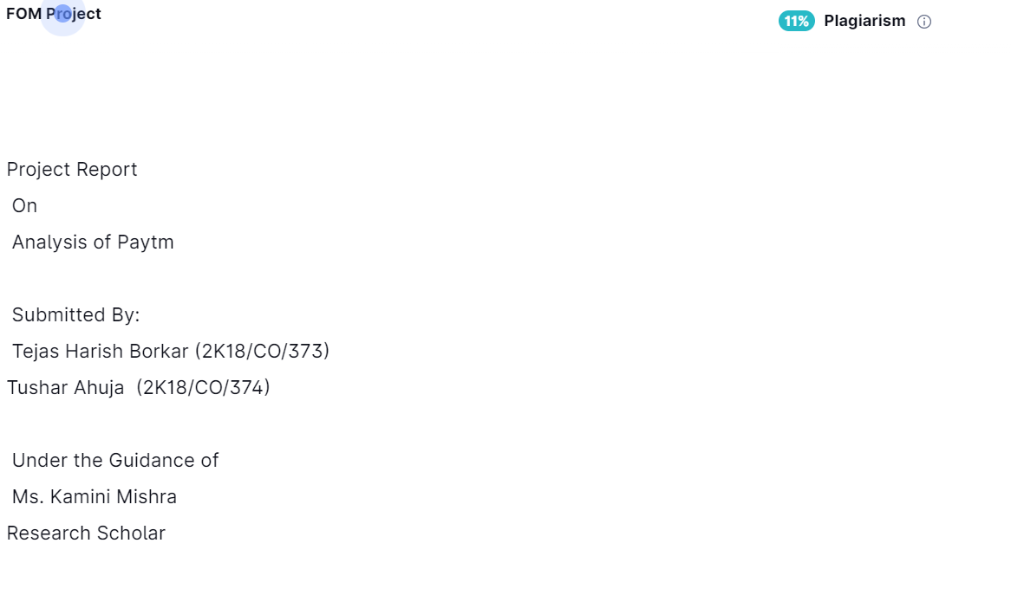

Figure 6 : Plagiarism Check